**COLLABORATIVE AND DECENTRALIZED SUPPLY CHAIN MODELS - IMPLICATIONS AND PRE-EMPTIVES**

* A retailer might collaborate with a wholesaler or manufacturer from which it purchases goods
* A manufacturer might collaborate with a raw materials supplier to add value for its end-customers
* A raw materials supplier might collaborate with one or more transport companies to generate service and cost benefits for its largest manufacturing customers

There was a time when supply chains were, in the main, vertically oriented. A single company might have owned the processes of raw material sourcing, manufacturing, distribution, sales, and marketing, with the entire supply chain falling under the direct control of that one enterprise.

The same is rarely true today. Most supply chains are decentralised, sometimes involving dozens of companies, all playing different roles in the demand/supply cycle. With no single entity having complete control of materials, resources, strategy, or service quality, collaboration is the only way to unify the supply chain.

However the concept of supply chain collaboration is not yet mature. In many cases, supply chains still comprise a mix of companies, some of which collaborate with one another, while others maintain traditional supplier/buyer relationships.

**A conceptual model of supply chain collaboration**

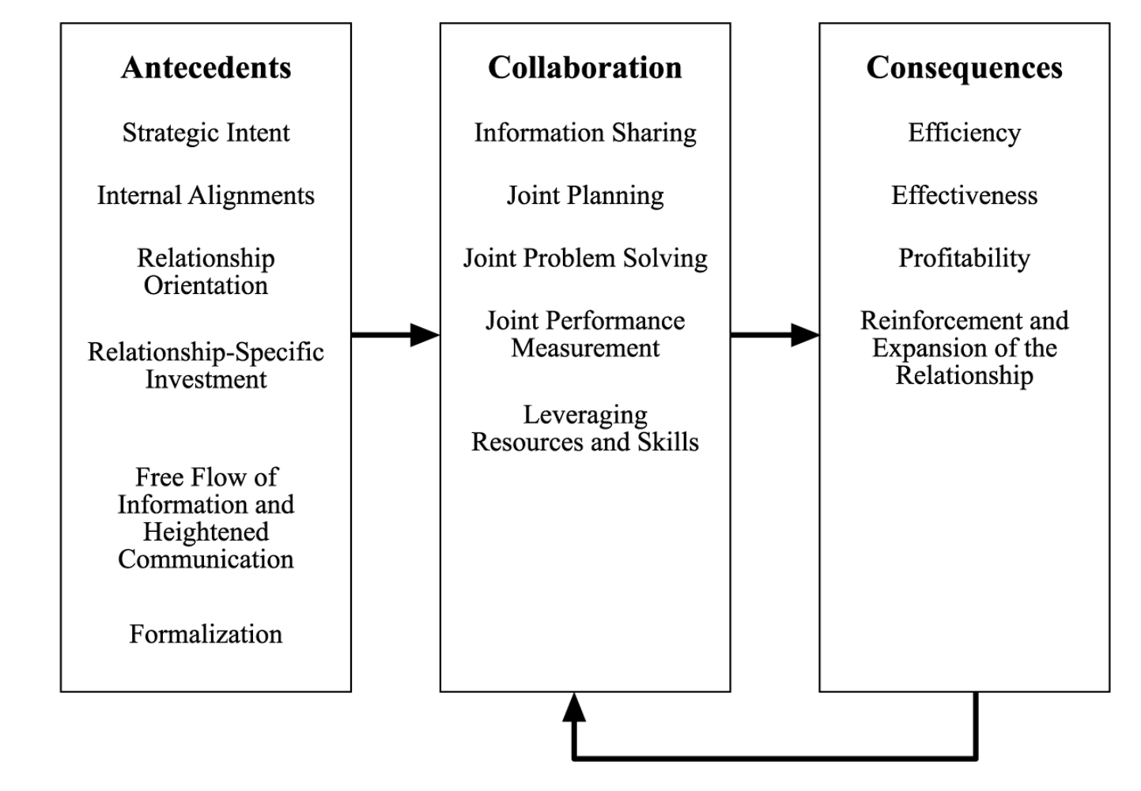

Antecedents of collaboration The responses to the question about what’s involved in developing a collaborative relationship centered in the following areas – s**trategic intent, internal alignments, relationship orientation, investments, free flow of information/heightened communication, and formalization.**

These areas are described in greater detail. -

**Strategic intent -** The survey respondents indicated that clear strategic intent leads to successful collaborative arrangements. For example, a firm’s objective to grow, capture market share, and/or improve service offerings with the help of collaborative partners can drive the entire supply chain collaboration process. Clear strategic intent provides focus for the collaborative relationship and shapes interactions to gain the greatest cross-firm rewards/improvements. Without such a roadmap, optimal results cannot be achieved.

**Internal alignments -** Supply chain collaboration requires firms to adopt a completely new business model and to work closely with a limited set of supply chain partners. The selection of the right supply chain partners is critical. One respondent recommended process mapping to define step-by-step supply chain processes. Process mapping can help to determine what can be done internal to the organization and what needs to be accomplished with an external partner. Creating internal alignments (and ultimately external alignments) can yield additional dividends by helping to streamline operations in basic areas such as manufacturing cycles, forecasting methods, customer service, sales, logistics, and information systems. Such alignments (that is matching) can create a seamless customer value delivery process. This may result in reconfiguration for the collaboration partners. A cautionary observation from the respondents noted that intended reconfigurations inside the firm could not be accomplished without top management support. As the respondents pointed out “only the top management’s attention to changes” will drive the necessary adjustments toward external collaboration.

**Relationship orientation -** Many of the respondents expressed the need to emphasize the development of a relationship (versus a transactional orientation) and understanding of each other’s business. Of course, that’s to be expected. However, the responses also gave an indication of what relationship development means in practice. The common thread IJLM 16,2 242 was ongoing, long-term interactions built on mutual trust and commitment. One respondent likened a collaborative relationship to a work-in-progress.

**Relationship-specific investment** Sustainable collaborations must be supported with sufficient resource investments. Financial and non-financial investments including time, money, training, technology up-dates, and other resources are required. Respondents also talked about a different type of investment – top management’s attention. Unless support is provided by people with power within the organizations, the long-term outcome is at risk. The return on investments at the respondent firms seems to be positive. Several respondents explicitly stated building and maintaining relationships and then dedicating personnel to managing the relationships, the processes, and the information was worth the effort. They also pointed out that collaborative relationships do not thrive unless they are encouraged and supported through sufficient commitment of management time. Time may be the costliest investment.

**Free flow of information** heightened communication Information sharing between the collaborative partners occurs in a variety of forms that include point-of-sale (POS) data, promotion plans, insights into inventory levels, etc. Information sharing was described as a “two-way street”.

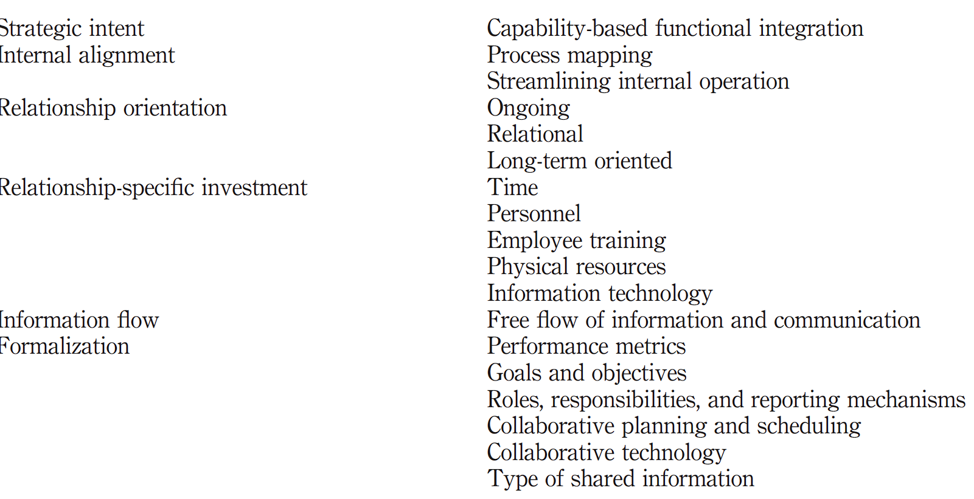

**The areas of formalization suggested by the respondents include:**

1. **co-developing performance metrics**
2. **key performance index, scorecard, product/service deliverables – and the resulting incentive;**
3. **prior agreements on collaboration goals or objectives;**
4. **determining roles and responsibilities of each partner as well as reporting mechanisms in the relationship;**
5. **laying out collaborative implementation plans;**
6. **standardizing information technology;**
7. **specifying information to be shared;**
8. **aligning collaboration schedules.**

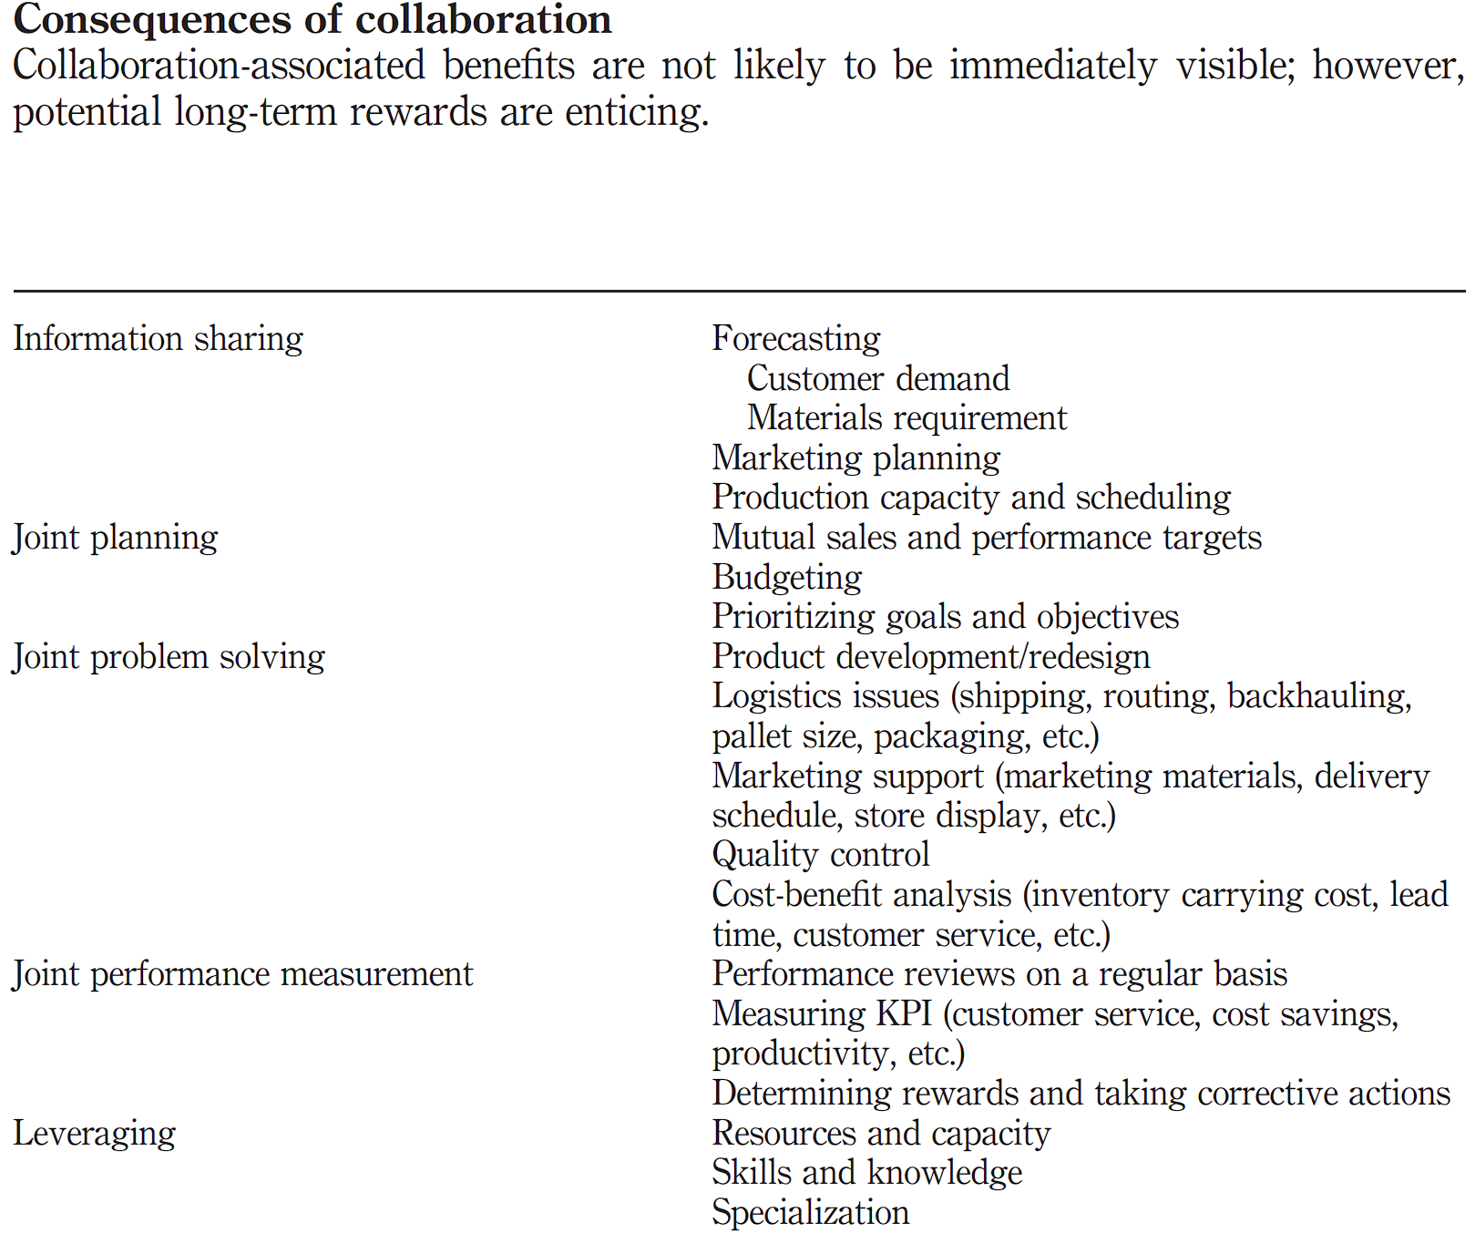

**Efficiency, effectiveness, and profitability -** In terms of the specific outcome of collaborative efforts, as expected, the responses centered in traditional performance areas. For example, efficiency and effectiveness were frequently mentioned. Efficiency is the measure of how well expended resources are utilized; effectiveness refers to the extent to which goals are accomplished (Mentzer and Konrad, 1991). The survey respondents reported benefits such as efficiency (e.g. cost reduction, reduced inventory, shortened lead-time, streamlining supply chain process, etc.), effectiveness (improved customer service, increased market share, increased sales, new product development, etc.), and profitability. For example, a manufacturer and its customer developed store-ready pallets of product to minimize handling issues at the customer’s distribution centers. Another example is found in new product development. Several manufacturers commented that collaboration with their customers generated a better, more profitable marketing mix as well as new product ideas.These benefits can also be achieved by leveraging potential synergistic effects associated with achieving economies of scale and/or acquiring complementary resources and capabilities. For instance, two respondents indicated collaboration has helped their companies maximize asset utilization (e.g. truckload transportation, transportation capacity sharing, etc.) resulting in substantial capital relief. In addition, several panel members acknowledged that designing/redesigning logistics processes optimized product/service flows and reduced retail store inventory levels. Respondents reported numerous examples to illustrate how collaboration can be financially rewarding through the coordination of procurement activities. One retailer was able to reduce thermal packaging-related costs by 12 percent and their vendor partner boosted profit by 8 percent as a result of adjusting sourcing scheduling. Another retailer talked about his company’s decision to allocate more sales promotion dollars to their collaborative trading partner. The decision resulted in significantly increased transaction volume between the two collaboration partners.

**Reinforcement and expansion of the relationship -** True collaboration evolves over time as the partners explore the potential for mutual benefits. The respondents mentioned the need to understand and share each other’s value systems in order to build a strong base for collaboration. Firms usually work with a very limited set of potential partners to test the waters. This typically requires a series of exploratory sessions to discuss expectations and to determine whether there is sufficient fit between the organizations to warrant further exploration. If both parties are satisfied with the relationship, collaboration involvement is likely to escalate as they begin to trust each other. One respondent described reaching a level of comfort after the collaborative partner had met all agreed upon contractual performance requirements. As a result, “more doors were opened” with respect to information sharing and resource commitment. The openness of a collaborative relationship can establish a hotline between collaboration partners, link each other’s information systems, promote candid input from trading partners, encourage development of mutual business plans, and – in extreme cases – result in opening “the books” to each other.

The complex dynamics of the supply chain mean that expectations of collaborative partners change – usually escalate – over time. As expectations and the relationship are examined, a new focus often emerges. This commonly prompts a re-evaluation of goals, objectives, performance metrics, and rewards. A respondent pointed out that when a collaborative arrangement grows and succeeds, all parties feel a sense of ownership. As such, mutual cooperation is strengthened. This is consistent with commonly proposed best business practice. One of the primary motives for working together through collaborative efforts is to gain operational and competitive advantages such as decreased cycle times, lower inventory and operating costs, and increased efficiencies in process activities.

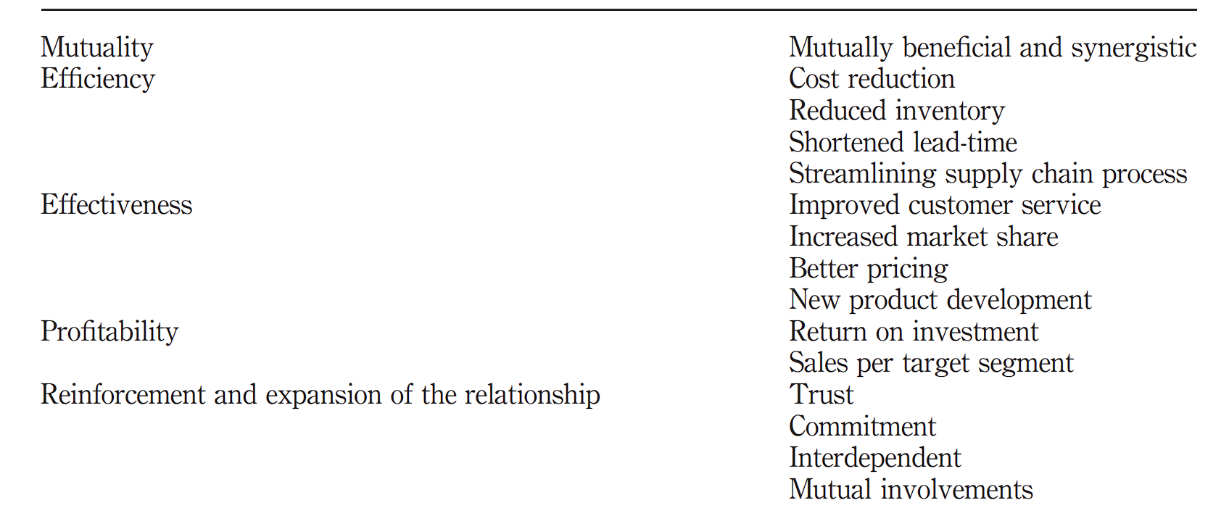

**TWO IMPORTANT THINGS TO BE KEPT IN MIND GOING TOWARDS A SUCCESSFUL COLAB MODEL -**

**FIRST**, the survey respondents placed emphasis on the need to formalize collaboration arrangements (e.g. detailing of performance metrics as well as goals and objectives) as an important prerequisite and foundation for collaboration.

**SECOND**, collaborations that are successful often result in the development of a new culture and operating atmosphere. One respondent mentioned working in an environment that encouraged the “spirit of achieving a mutually profitable relationship”. Another said that collaborative relationships should “bring the greatest good to the greatest number of people in an honest and mutually beneficial manner”. Within this context, several of the respondents pointed out that collaboration evolves over time as the parties get to know one another. Jointly shared experiences can help them “learn how to leverage certain areas to create and exploit opportunities”. These cultural changes forge supply chain relationships that, in turn, reinforce collaborative efforts.

**THREE-STAGE SC COLLABORATION MODEL WITHIN A FORCE FIELD FRAMEWORK**

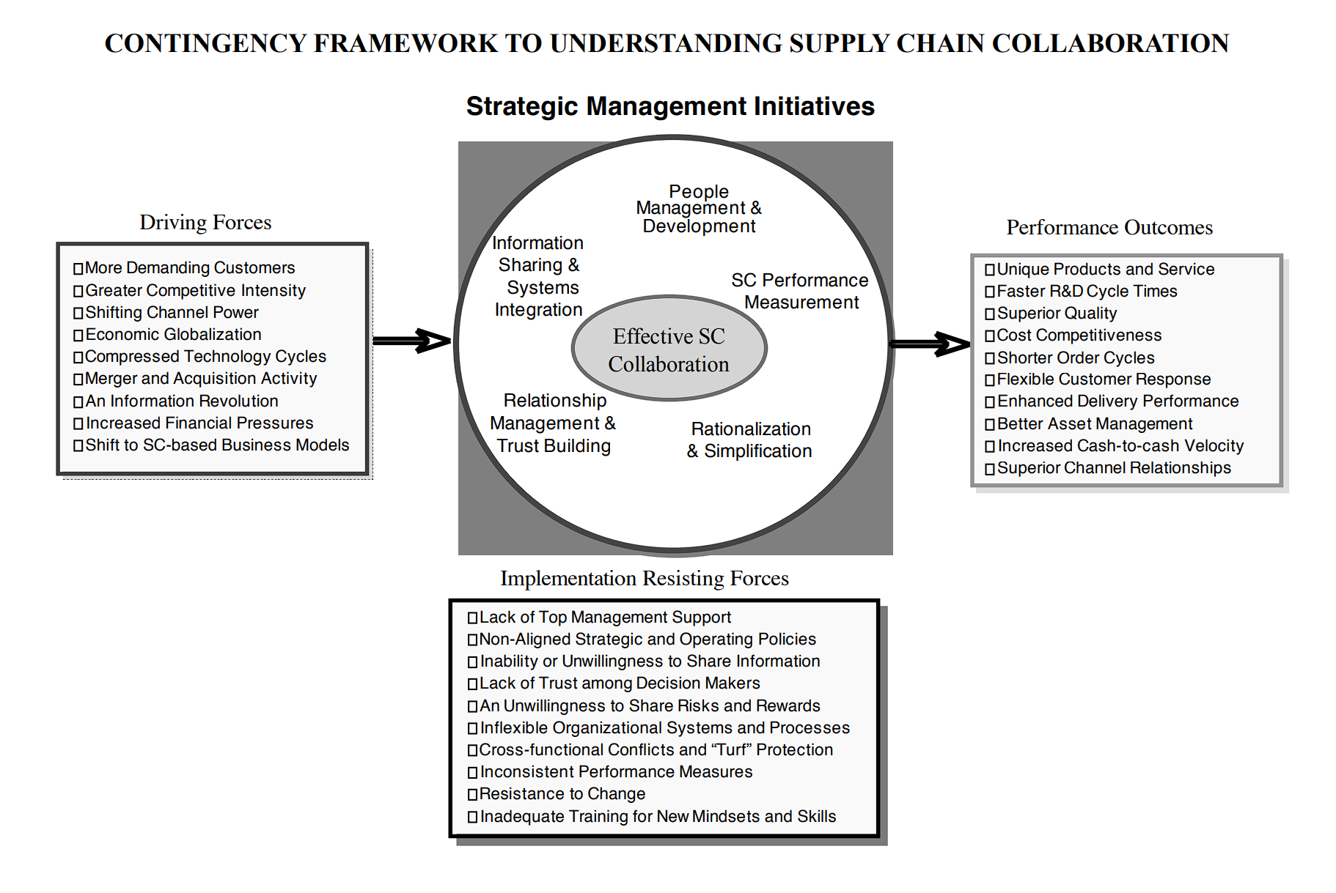

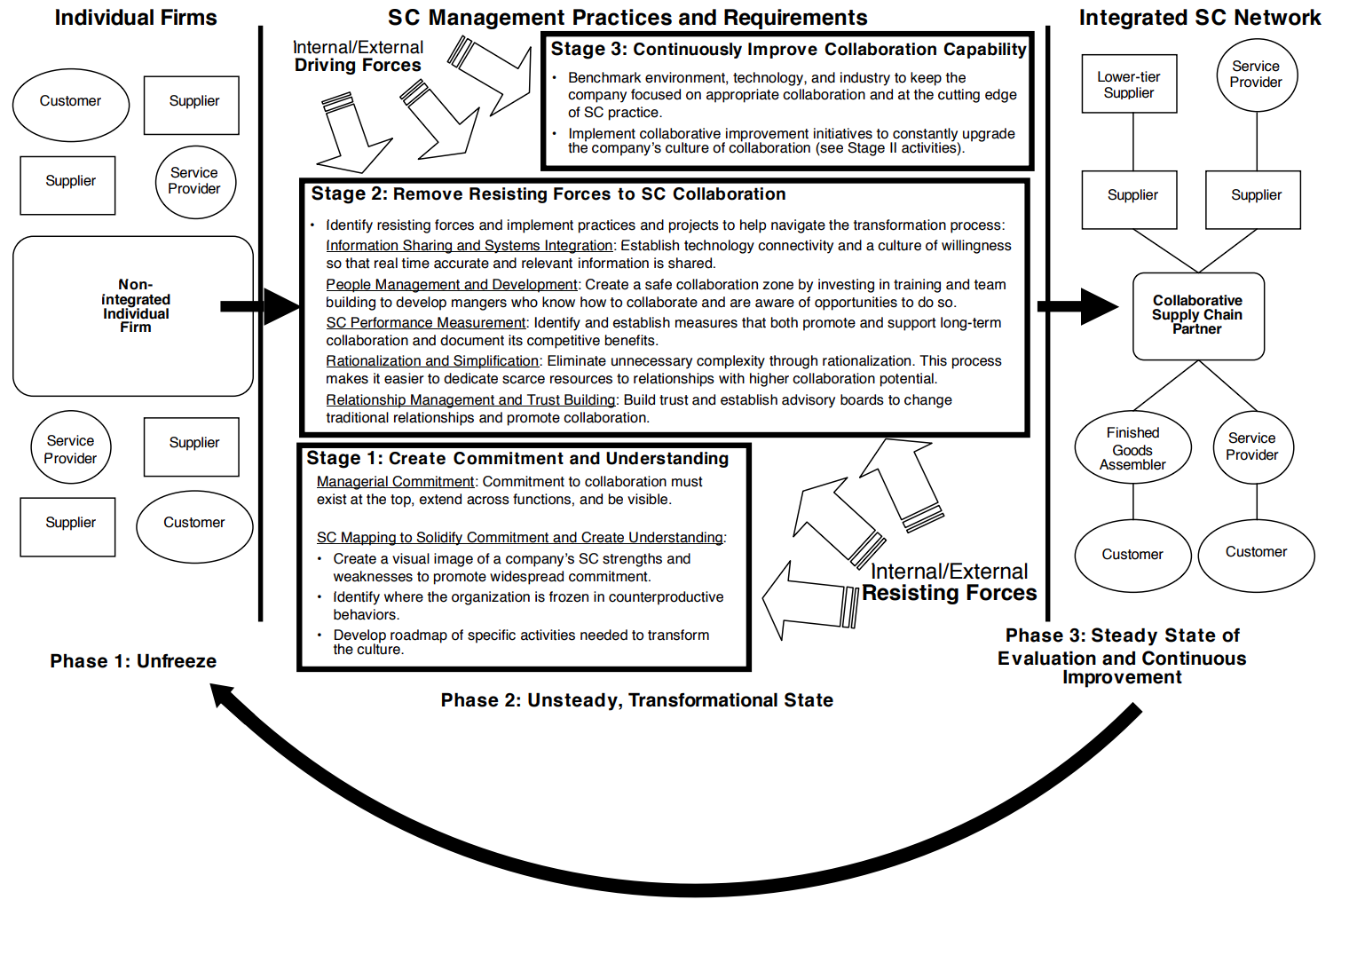

**Factors affecting collaboration in the supply chain:**

1. **Commitment:** Commitment refers to the willingness of trading partners to exert effort on behalf of the relationship and suggests a future orientation in which firms attempt to build a relationship that can be sustained in the face of unanticipated problems.
2. **Trust:** A positive belief, attitude, or expectation of one party concerning the likelihood that the action or outcomes will be satisfactory.
3. **Adaptations:** As investments of a customer in the supplier’s knowledge, structures, and processes to make use of its resources
4. **Relationship promoter of the customer**: RP are persons who intensively shape and advance inter-organizational exchange processes; they do so based on their network of good personal relationships.
5. **Stakeholders:** All the players of the supply chain are referred to as stakeholders—the supplier, the manufacturer, the distributor, the wholesaler, the retailers, and the customer.
6. **Topology:** Supply chain configuration is referred to as topology. Example convergent or divergent.
7. **Enabling technology:** Information technology used in the supply chain is referred to as allowing technology—for Example, MIS, TPS, DSS, ERP, EIS, etc.
8. **Level of collaboration:** The market environment and business strategy determine which level(s) collaboration is suitable and beneficial. Levels of cooperation defined are at the operational, managerial, and strategic levels.
9. **Business strategy / Goal congruence:** Goal congruence between supply chain partners is the extent to which supply chain partners perceive their objectives are satisfied by accomplishing the supply chain objectives. It is the degree of goal agreement among supply chain partners. “the degree to which two entities’ objectives are compatible” Processes.
10. **Integrated processes Innovative supply chain process:** Integrated supply chain processes refer to how the chain members design efficient supply chain processes that deliver products to end customers promptly at lower costs.
11. **Collaborative communication:** Collaborative communication is the contact and the message transmission process among supply chain partners regarding frequency, direction, mode, and influence strategy.
12. **Dependence and interdependence Long-term relationship Joint relationship effort**: Dependence refers to a firm’s need to maintain an exchange relationship to achieve desired goals. The structure (magnitude and relative symmetry) of this ‘reciprocal’ dependence characterizes the level of interdependence in the relationship and has necessary implications for interaction; joint efforts, such as planning, goal setting, performance measurement, and problem-solving, are essential for successful collaborative relationships.
13. **Co-operation:** Co-operation refers to situations in which firms work together to achieve mutual goals
14. **Legal protection coordinative structures collaborative agreement** :

It depends on the extent to which detailed formal legal rules and

doctrine exists, the design and operations of the institutions that implement them, and the so-called legal culture encompassing customs, opinions, and the ways of doing and thinking that define people’s practices of and attitudes toward laws. The collaborative agreement is another essential element to manage differences in an integrative inter-firm relationship; coordinative structures and mechanisms consist of a series of activities, structurally identified by either and the manufacturer.

1. **Government support**: Governmental intervention in business activities. Local governments exert more direct influences by implementing formal and informal policies related to economic activity.
2. **Interpersonal relationship:** The term guanxi refers to networks of informal, personal relationships and exchanges of favors that dominate business activities
3. **Information sharing**: Information sharing refers to the exchange of critical, often proprietary, information between supply chain members through media such as face to face meetings, telephone, fax, mail, and the Internet to the extent to which a firm shares a variety of relevant, accurate, complete, and confidential information promptly with its supply chain partners.
4. **Collaborative planning**: Collaborative planning refers to collaborations among trading partners to develop various plans such as production planning and scheduling, new product development, inventory replenishment, and promotions and advertisement.
5. **Decision synchronization Joint decision making**: Decision synchronization refers to the process by which supply chain partners orchestrate decisions in supply chain planning and operations that optimize the supply chain benefits.
6. **Incentive Alignment:** Incentive Alignment refers to the process of sharing costs, risks, and benefits among supply chain partners.
7. **Resource sharing Asset specificity:** Resource sharing refers to leveraging capabilities and assets, investing in faculty, and helping supply chain partners. Resources include physical resources, such as manufacturing equipment, facility, and technology.
8. **Dedicated investments:** Dedicated investments refer to investments made by a buyer or supplier dedicated to a relationship with a specific supplier or buyer, respectively.
9. **Joint knowledge creation Knowledge sharing Collective learning :**

Collaborative knowledge creation refers to the extent to which supply chain partners develop a better understanding of and response to the market and competitive environment by working together.

1. **Information availability:** Information availability is referred to the extent to which relevant information is available to all participants within a supply chain equally, beyond the information which is actively shared between partners within the supply chain
2. **Information quality:** Information quality includes aspects such as accuracy, timeliness, adequacy, reliability, credibility, understandability, and ease of use of the information exchanged.
3. **Behavioral uncertainty:** Behavioral uncertainty refers to the potential inherent in a situation for difficulty anticipating and understanding the actions of partners
4. **Cultural difference Organizational culture:** Organizational culture is defined as shared values and beliefs that can help understand organizational functioning and provide behavioral norms. The collective programming of the mind distinguishes the members of one group or category of people from another. Differences in organizational or social levels could create differences of opinion or conflicts of interest.
5. **Management controls Integrated policies:** Updating of Formal agreement, Comprehensive plan outlining common goal, requirement, and expected benefits. Determine the extent of sharing—rewards/risks sharing scheme.
6. **Management commitment:** The management from both companies has to view the partnership as a shared growth strategy and be fully committed to trusting each other to act in their mutual best interest.
7. **Supplier performance Collaborative performance system:** Defined as the process of devising and implementing performance metrics that guide the chain members to improve overall performance.

Variables affecting collaboration in the supply chain

1. Raw Materials

While most companies may have commodity raw material they need to pay particular attention to – such as cocoa for Cadbury or leather for a footwear company – there is a host of other raw materials that are less prominent in the consumer consciousness. However, if the pattern of increasing scrutiny of raw material supply chains is set, companies will progressively have to pay closer and closer attention to where it sources everything. Deciding which to focus on while developing systems that may eventually be applied to all raw materials is therefore likely to be important.

1. Raw material suppliers

A manufacturer might collaborate with a raw materials supplier to add value for its end-customers. A raw materials supplier might collaborate with one or more transport companies to generate service and cost benefits for its largest manufacturing customers.

1. Inventory facilities

Inventory costs are linear functions of facility capacity and amounts of material stored.

1. Production facilities
2. Distribution centers

In a shared supply chain, two or more companies use the same distribution facility and transportation services to serve mutual customers. This practice reduces costs for manufacturers and provides more frequent replenishment for retailers.

1. Retail/Customer centers

A retailer might collaborate with a wholesaler or manufacturer from which it purchases goods.The exclusive nature of their relationship helps private-label manufacturers and retailers achieve true integration and collaboration more easily. As a result, they often share assets as well as information. For instance, a manufacturer may deliver directly to a retailer’s consolidation centers to avoid the cost of owning and maintaining its own warehouses. Or, the manufacturer might share the retailer’s distribution fleets, which also simplifies logistics and reduces costs.